DARSHAN PATEL

FORDHAM UNIVERSITY GABELLI SCHOOL OF BUSINESS

ISGB 799Z – DEEP MACHINE LEARNING – SPRING 2019

Assignment 3

ExeCUTIVE SUMMARIES FOR nvidia Deep learning AI Courses exercises

Classifying Medical Images

1. Research Question

In this study, a set of 90,000 medical images is made where each image needs to be grouped into whether it shows a scan from a specific body part. The different scan types are: “chestCT”, “CXR”, “AbdomenCT”, “Hand”, “HeadCT” and “BreastMRI”.

1. Method

To classify the images, a convolutional network is made. The network will use two hidden convolutional layers to reduce the dimensions of the images. The images then go to two hidden fully connected layers so that information about the image can be gathered and then finally to an output layer which then predicts what is the type of scan.

1. Results and Discussion

With each run of the image dataset, the neural network performed with decreasing training loss. After 14 runs, the loss in the training data went from 94% to ~4%, whereas the validation loss went from % to ~5%, as seen in Figure 1. The model stopped running when the validation loss is greater than the halting threshold. It can be concluded that with 14 epochs, or run throughs of the dataset, the model performed with the lowest loss in new data.

1. Conclusion and Implications

In this study, a convolutional network was used to classify medical images into several different types of scans. It was found that after a few run throughs of the data, the model performed with 98.4% accuracy on the test set. Figure 2 shows the labels the neural network gave to 9 different medical scans. Despite identifying the scans, it is yet confusing to interpret them since it is possible that the neural networks may classify scans with abnormalities into the wrong scan type.

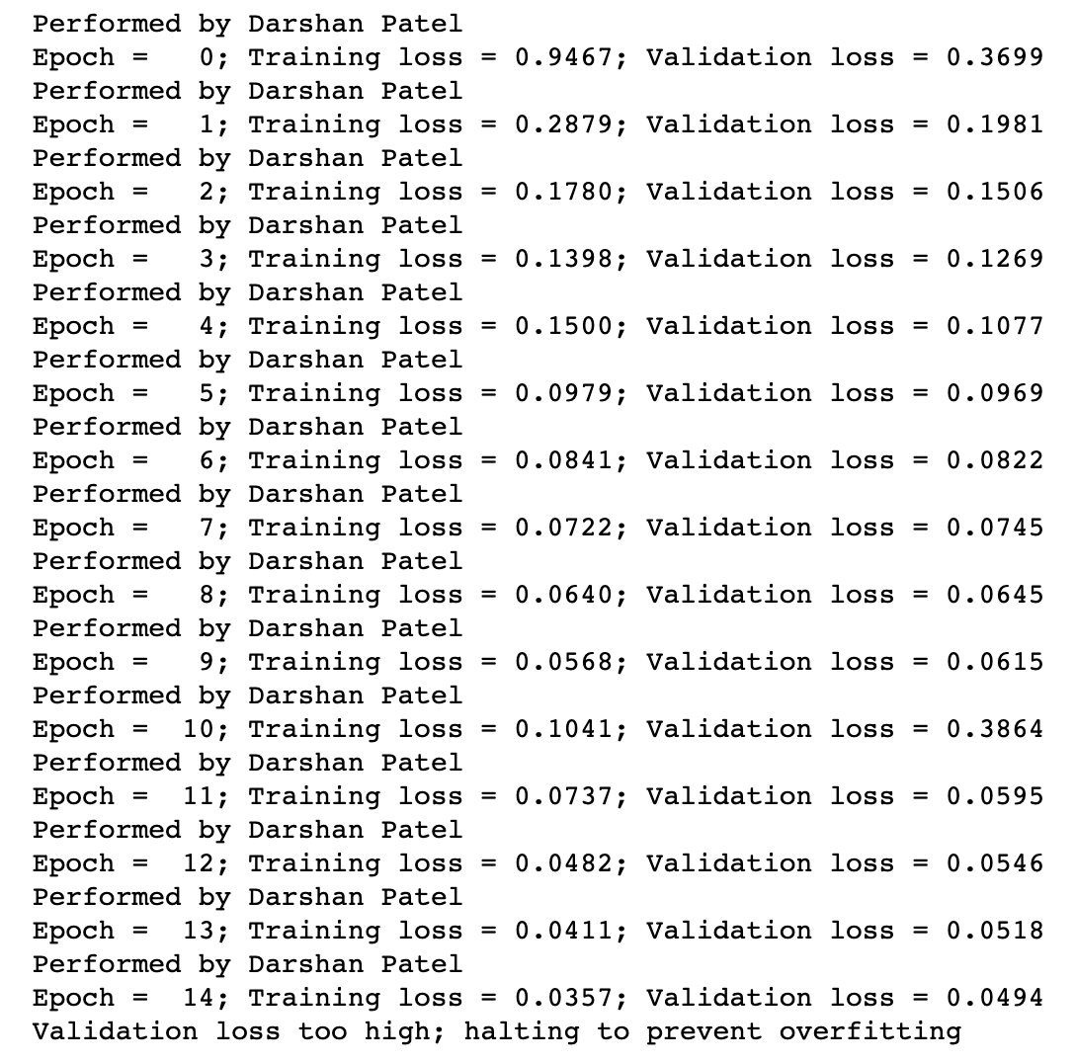

Figure 1

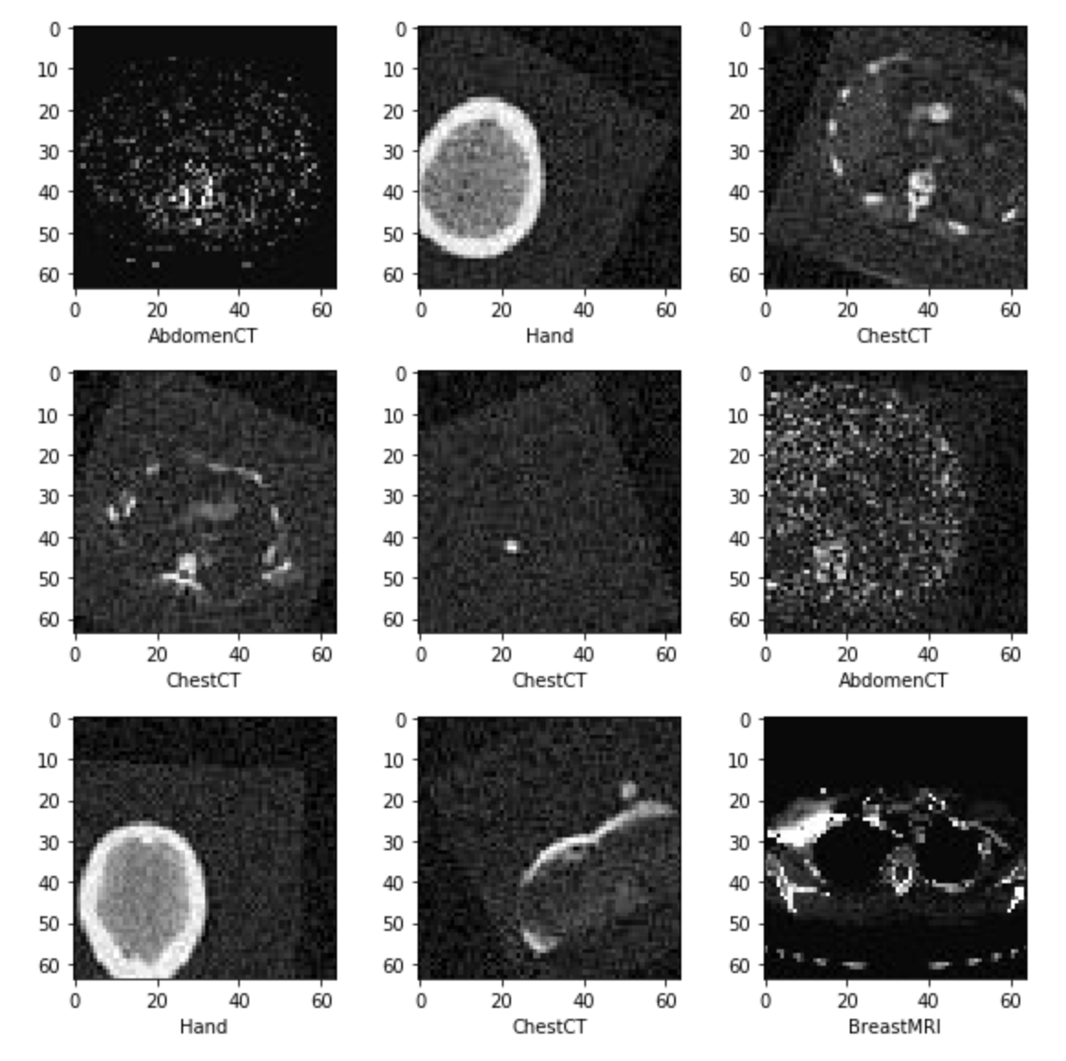

Figure 2

Classifying Income

1. Research Question

In this study, a number of features about individuals is shared, such as age, gender and occupation. The goal is to determine whether or not the individuals’ income exceeds $50,000 a year.

1. Method

The input data is transformed into tensors for learning in the neural network. Using a linear classifier to perform logistic regression, a model was created to identify individuals’ income level (above or below $50,000).

1. Results and Discussion

It was found that when using the values already given in the dataset, the model performed with 82.9% accuracy on the data it has not seen, as seen in Figure 3. When the model was trained using data created from the existing columns, there was a small boost in accuracy of 0.4%. When techniques were applied to generalize the model, the accuracy fell down to 82.3%.

1. Conclusion and Implications

Classifying incomes helps to determine economic status of the country. It was found that by using several basic features about people, a neural network model was able to correctly classify income levels at a rate of nearly 83%. This value could be improved on using more advanced types of neural networks or by adding layers. In addition, the use of adding derived data did not help to properly classify income levels. Proper knowledge of what could be valuable and add new information could be taken into consideration for future modeling.

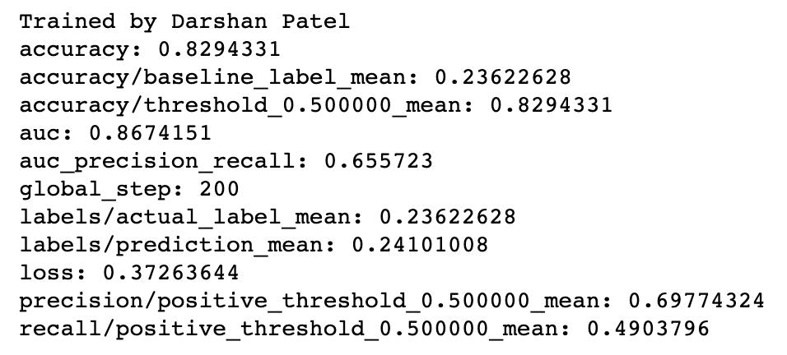

Figure 3

Removing Noise From Images

1. Research Question

The goal of this study is to create a mechanism to remove extraneous noise from pictures without sacrificing image quality.

1. Method

Using 460 images, a denoiser is built using 17 convolutional layers to create an autoencoder network. It is trained using only RGB images.

1. Results and Discussion

It is found that after training the neural network for 20 run throughs of the images, the training loss decreases from 16% to 4%, as seen in Figure 3. On a new image of a bistro bar which is heavily pixelated, the network is able to denoise it by color and achieve a SSIM index of 63-67% per color.

1. Conclusion and Implications

An autoencoder network was used to help reduce noise in image files. With the help of 17 convolutional layers, the network was able to do denoise images at a high rate. Although it is successful, it can be improved on. Ways to do this include increasing number of run throughs of the data, decreasing the crop size of the image before comparisons are done or increasing mini batch size. The model in this study was trained using a small number of samples but for real world use, a large number of images would be needed. This model can be used to clean up old images from the late 1800s and 1900s. It can also be used in criminal cases to uncover mysteries in damaged pictures of crime scenes. In the future, this method could get adapted into use for multiple frames, like for videos.

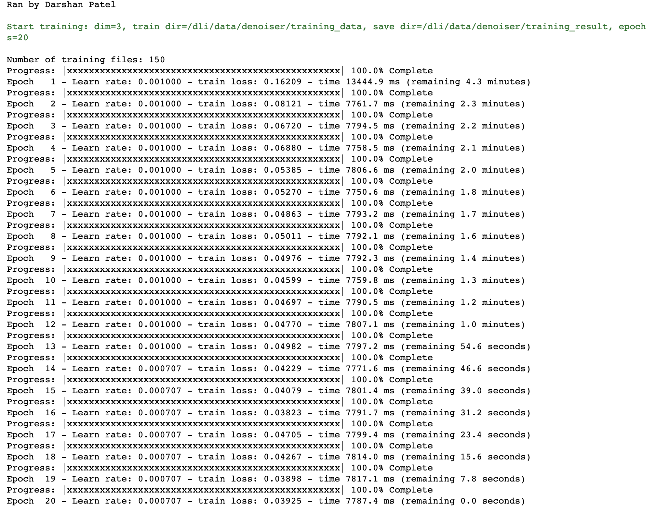

Figure 4

Classifying Binary Genomic Sequences

1. Research Question

In this study, a collection of genomic sequences will be simulated twice. In one set, instances of homotypic motif clusters will be in the center of sequence whereas in the other, the motif instances will be placed anywhere. The goal is to classify the sequences between center of sequence or not.

1. Method

To build a model, a DragoNN model will be created; this consists of 3 convolutional layer and 15 convolutional filter. It will also have a ReLU thresholding and maxpooling mechanism. To aid in preventing errors, a regularization technique will be used on each convolutional layer.

1. Results and Discussion

After training the network, loss becomes fairly constant in the unseen data after 40 run throughs of the data, as seen in Figure 5. It is not until almost 100 run throughs that the algorithm stops, when the difference in loss between training and validation is high. A plot of the effect on feature discovery is shown in Figure 6. What happens now is that one of the variables, TAL1_known4, is highlighted more in one outcome than the other. This means that the model lost feature discovery ability, since it is not balanced.

1. Conclusion and Implications

A convolutional network was used to classify genomic sequences. It was found that with 40 run throughs of the data, the model will classify homotypic motif clusters with high accuracy. Further modeling techniques can be done to attempt to balance feature discovery.

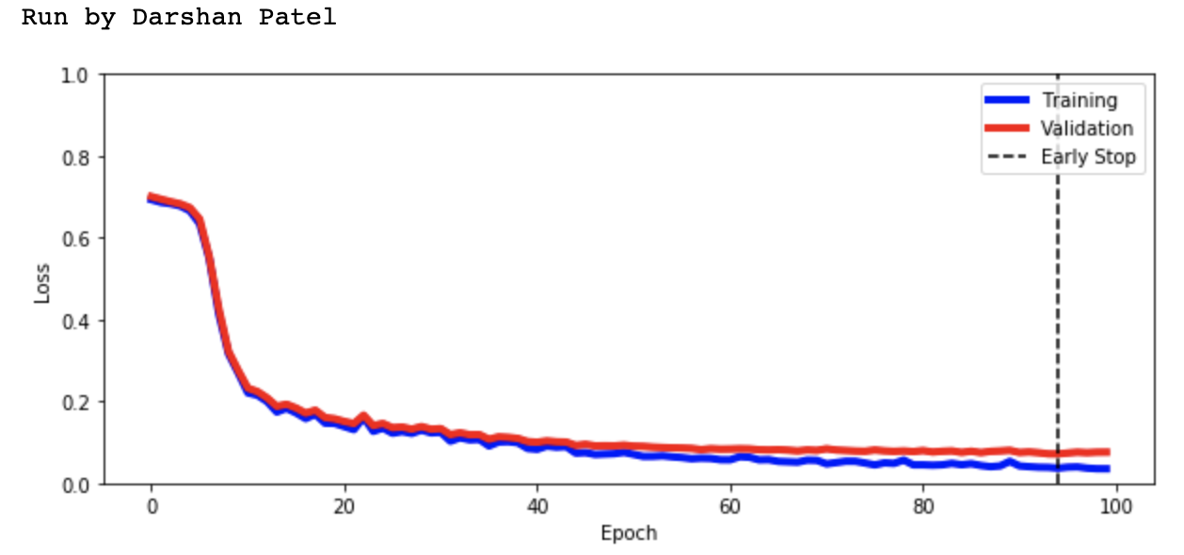

Figure 5

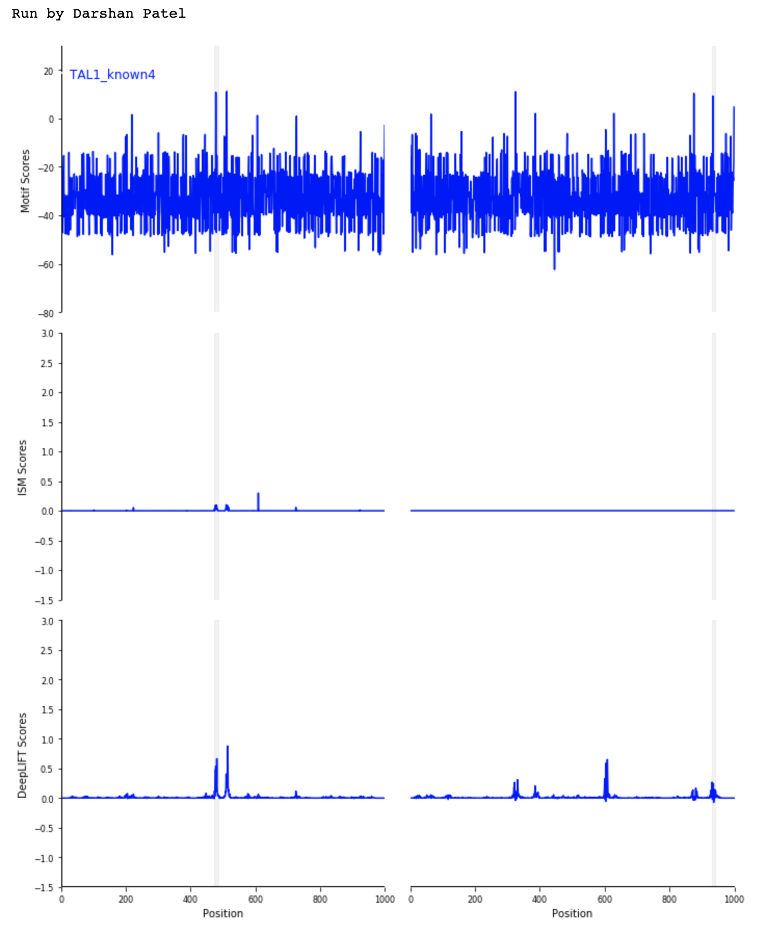

Figure 6